SOLUTION OF SIMULTANEOUS ALGEBRAIC EQUATIONS

GUASSIAN ELIMINATION METHOD
AIM: TO WRITE A PROGRAM IN PYTHON TO DEMONSTRATE GUASSIAN ELIMINATION METHOD

PROGRAM:
#Gaussian elimination with partial pivoting row operations
# Solve the system:
# x1 + 10 x2 - x3 = 3
# 2x1 + 3 x2 + 20 x3 = 7
# 10x1 - x2 + 2 x3 = 4
# Augmented matrix (each row: [a11, a12, a13, b])
A = [
[1.0, 10.0, -1.0, 3.0],
[2.0, 3.0, 20.0, 7.0],
[10.0, -1.0, 2.0, 4.0]
]
n = len(A) # Number of equations/variables (n=3)

def print_matrix(M: List[List[float]], msg=None) -> None:
"""Prints the augmented matrix with 10.6f formatting."""
if msg:
print(msg)
for r in M:
# Join values with spaces, formatting each to 10 characters with 6 decimal places
print("[" + " ".join(f"{val:10.6f}" for val in r) + "]")
print()
SIWS COLLEGE PRACTICAL NO 4

def swap_rows(M: List[List[float]], i: int, j: int) -> None:
"""Swaps row i and row j in matrix M and prints the operation."""
M[i], M[j] = M[j], M[i]
# Print R(i+1) <-> R(j+1) to use 1-based indexing for output
print(f"R({i+1}) <-> R({j+1})")
print_matrix(M)

def scale_and_add(M: List[List[float]], col: int, factor: float, row: int) -> None:
"""
Performs R_dest = R_dest - k * R_src.
In the context of elimination, row is dest (row to eliminate in), col is src.
"""
n_cols = len(M[0])

# Print R(dest+1) <- R(dest+1) - (k) * R(src+1) to use 1-based indexing
print(f"R({row+1}) <- R({row+1}) - ({factor:.6f})*R({col+1})")

# Perform the operation: M[row] = M[row] - factor * M[col]
for c in range(n_cols):
M[row][c] = M[row][c] - factor * M[col][c]

print_matrix(M)

# --- Main Solution Logic ---

# Work on a copy of the augmented matrix
M = deepcopy(A)
print_matrix(M, "Initial augmented matrix [A | b]:")
SIWS COLLEGE PRACTICAL NO 4

for col in range(n):
# Partial pivot: find row with max abs value in column 'col' from rows col..n-1
# max() returns the row index 'r'
pivot_row = max(range(col, n), key=lambda r: abs(M[r][col]))

if pivot_row != col:
swap_rows(M, pivot_row, col)

pivot = M[col][col]

if abs(pivot) < 1e-12: # Check for near-zero pivot (singularity)
raise ValueError("Zero pivot encountered")
# Eliminate below
for row in range(col + 1, n):
factor = M[row][col] / pivot
# scale_and_add(Matrix, source_row, factor, destination_row)
scale_and_add(M, col, factor, row)
print("Upper-triangular matrix after forward elimination:")
print_matrix(M)

# Back substitution
x = [0.0] * n # Solution vector [x1, x2, x3]

# Loop backward from the last row (n-1) to the first row (0)
for i in range(n - 1, -1, -1):

SIWS COLLEGE PRACTICAL NO 4

# s is the RHS (augmented column), which is M[i][n]
s = M[i][n]
# Subtract known x[j]'s multiplied by their coefficients M[i][j]
for j in range(i + 1, n)
s -= M[i][j] * x[j]
# Solve for x[i]
x[i] = s / M[i][i]
# Print Solution vector
print("Solution vector:")
# Enumerate x starting from 1 for x1, x2, x3 display
for i, xi in enumerate(x, 1):
print(f"x{i} = {xi:.8f}")

OUTPUT:

SIWS COLLEGE PRACTICAL NO 4

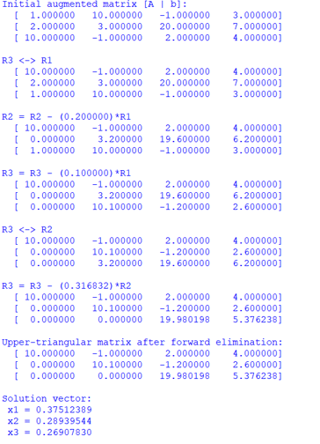
CONCLUSION:
THE ABOVE PROGRAM HAS BEEN EXECUTED SUCCESSFULLY.

